GAD132 Readings & Assignments: Week 3
Week 3 Reading
Complete the following reading early in the week:
Week 3 online lectures.
Use a search engine to find online articles on the following topics:
* Storyboard
* Storyboarding for Games
The following sections from The Animators Survival Kit: A Manual of Methods, Principles and Formulas:
* The X Sheet
Week 3 Assignments Overview
Assignment Summary: Week 3 | Due Date
Assignment 1: Sketches and Discussion | Friday, September 5, 2008
Assignment 2: Tripping Tim Final Project: Creating a Background | Friday, September 5, 2008
Assignment 3: Tripping Tim Final Project: Animating Tim | Sunday, September 7, 2008
Assignment 4: Sketching | Tuesday, September 9, 2008
Using the navigation on the left, please proceed to the next page.

Introduction to Storyboard
A storyboard is the visual representation of a narrative or script that tells a story. It looks similar to the pages of a comic book that has illustrations accompanied by text. In the entertainment industry, after the director approves the final concept for an animation, a script is written detailing the events and dialogs in the story. But it's often difficult for all the artists (comprising members of the creative and development teams) to visualize the story in the same light as the script. That's where the storyboard comes in; it depicts the events of the story scene-by-scene. Visual illustrations make the story more comprehendible for the team.
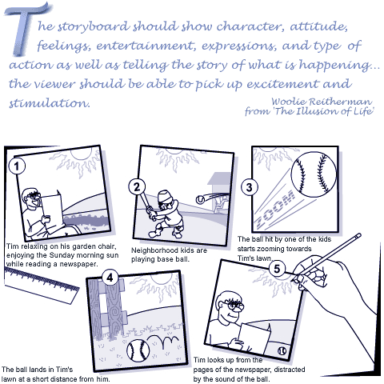
Storyboarding is an essential component in the preproduction stage of industries such as animation, movies, television commercials, music videos, soap operas, and gaming. It acts as a blueprint of the final animated product. Alteration of any part of the story is simpler when done at the storyboard stage than at any later stage. It's an accepted industry standard that production should not commence until a satisfactory storyboard is developed, and the creative and technical problems that may occur during the production are considered.
Learning Outcomes:
- Draw facial expressions of a character.
- Identify the different camera techniques in animation.

Components of a Storyboard
- A storyboard consists of a series of sketches drawn in separate frames called scenes. Each scene constitutes a key event in the course of the story. Since the purpose of a storyboard is to communicate story ideas to different artists in the initiation of the film or animation, strict cinematic continuity should be avoided.
- The sketches in the storyboard scenes are rough line drawings only meant to show the action. Suppose a story starts with a character meeting his neighbor on the jogging track and wishing him "good morning." To show this, you could draw a character in a running posture, mouth slightly open as if forming words, and another character approaching the scene from the opposite direction.
- But in the above example, how can you make the team understand what the character is saying? By writing the corresponding dialog below the scene.
- Dialogs are one of the ways of adding clarity to the storyboard scenes. You can also include short notes stating the location or sound effects that are necessary. Sometimes an arrow is marked to indicate the direction of action.
Explore:
Story and Storyboards: http://mag.awn.com/index.php3?ltype=search&sval=storyboards&article_no=1740&page=1
Storyboard Examples: http://www.storyboards-east.com/storybrd.htm
Storyboard Parameters
The idea of drawing a storyboard is to communicate in as much detail as possible the movement, development of actions, and expressions of the characters involved in each scene. To emphasize these features you need to consider the following parameters:
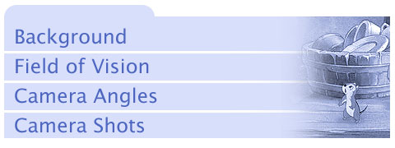
We'll take a closer look at each of these parameters in the following lectures.
There is no hard and fast rule as to who should develop the storyboard for a script. In a typical production team it can be the director who draws it, and in larger production houses there are special storyboard artists employed for the job.

Background and FOV
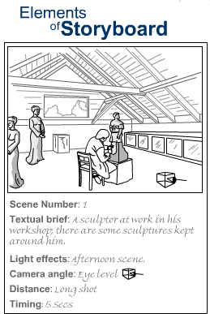
Background - The location at which each scene is set. The information for the background is generally stated in the script. In cases where it is not explicitly stated you'll need to visualize from the events in the story. For example if an incident in the script said "Tim slips on a banana peel and falls down," you may visualize the background to be his lawn, his neighborhood, a marketplace, or a country garden.
Field of Vision (FOV) - The area covered by the camera in each scene. For this, you must determine the number of characters to appear in each scene and the extent of background to be visible. When you're introducing the audience to the location of your protagonist's house, you want to show not only the entire house but its locale as well. If you want to show two kids playing in the yard, you may consider zooming in on the kids with just a portion of the house in the background. Remember, the unsolicited appearance of characters and background in a scene may remove emphasis from the important objects.
Sometimes you can show only part of an object (say a tall building) and let the audience assume the rest. This way you can increase the size of your canvas without actually creating all the objects for the background.
Storyboard examples:
http://www.storyboards-east.com/sb_flub.htm
Animation Layout – Getting perspective
http://mag.awn.com/index.php?ltype=pageone&article_no=1764&page=1

Camera Moves
Camera Angles
The perspectives that are used to bring out the spirit of an action or expression. Notice that in a storyboard, a straight camera perspective is only used in some scenes. Most of the scenes show the characters from different perspectives. This adds interest to the scenes. For example if several scenes show the interaction between two characters, you should vary the perspectives of the characters in each scene for a dramatic effect; otherwise, the scenes will appear too similar and boring. Think about the illustrations in comic books like Spiderman which depicted skyscrapers from a sharp slanted angle to exaggerate the height.
Generally a couple of standard camera angles are employed by production houses. They are:
High Angle: When the camera appears to be placed at a higher level than any of the characters in the scene. Think of an elephant's perspective of a mouse standing before it!
Low Angle: When the camera appears to be placed at a very low height so everything in the scene appears huge. Imagine a truant kid looking up at the strict principal—the kid's perspective of the principal. Or, consider the perspective of a mouse with an elephant towering over it. Artists use this perspective to make the character appear small, weak, and frightened.
Aerial: When the camera appears to be up in the sky looking down at the characters and location. This is also called a "bird's-eye view" of the scene. This is another very common technique used to introduce the audience to the place of the event.
Over the Shoulder: When the camera appears to be set on the shoulder of one of the characters in the scene, and therefore other objects are seen from the height of that character. In such a perspective, the back of the character is usually visible.

Camera Shots
Besides camera angles, there are several types of camera shots that can be used. These show the sizes of the characters or objects in relation to the frame of vision. Depending on the importance of an object in a scene, the camera will use one of the following shots:
Wide or Long Shot (WS or LS): Used to show a large setup, such as a big mansion, surrounding lawn, part of neighborhood, or a complete locale. The shots are also used to show a crowd scene without emphasizing any particular character. A WS or LS commonly introduces the audience to the place of action—they're often used in the first scene of a storyboard. Characters in a long shot are drawn full length.
Medium or Mid Shot (MS): Used to highlight specific characters or objects. Here the camera shows the character from the chest up. Consider using such shots when illustrating conversation between two characters or the gesture of a single character.
Close-up Shot: Used when the audience focus has to be captured on a particular object or part of an object. The camera zooms in on the object so that the background is barely seen. This type of shot accentuates expressions of characters. To represent a character deep in thought, draw a close-up of a face, eyes squinting, pursed lips and brow. Similarly, for inanimate objects, this shot shows details such as the keyhole in a door or a particular route on a map. An Extreme Close-up (ECU) will fill the frame entirely with a close-up of the object or person.
Point of View (POV) Shot : Used mostly to create suspense in a scene, to bring the reader close to a character's mood, thoughts and feelings, and to strengthen the action. For example, you might show a driver's POV of a winding mountain road, or an intruder's POV of a haunted castle.

Why Move the Camera?
Picture an airport scene. You see an airplane in the background and a huge crowd of people engaged in numerous activities. Two young women are hugging each other, apparently happy to be seeing each other after a long time apart. One of the women appears to be crying tears of joy.
What do you observe in the above scene? First, it's not one scene but a set of scenes in a single canvas: an airplane and crowds of people, two young women, and so on. The focus of each scene is slightly different from the previous scene, and with each shift in focus the area of attention narrows down from a crowd to a single individual. So the focus of attention is moving, capturing a different object each time. To animate the canvas the camera will have to be moved from one object to another to build the sequence of scenes.
In the entertainment industry, whether in movies, games, or animation, artists employ various camera movements through the story. Doing so creates dramatic effects and focuses on particular actions at particular points of time. To achieve such effects, artists use these standard camera moves:
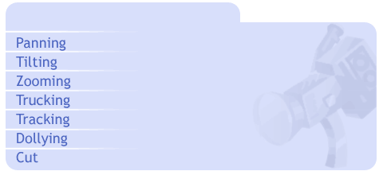
Note: The term camera in the context of animations refers to the movement of POV. The compositing software has a camera feature that is used for moving the background layers and characters. A real camera is also used in animation but this is used only for checking the flow of animation line in sequence and not for actual production.

X-Sheets
One of the primary uses of the X-Sheet is to determine the placement of keys and inbetween shots. As the production team continues to create backgrounds and character animations, the animator starts filling in the X-Sheets.
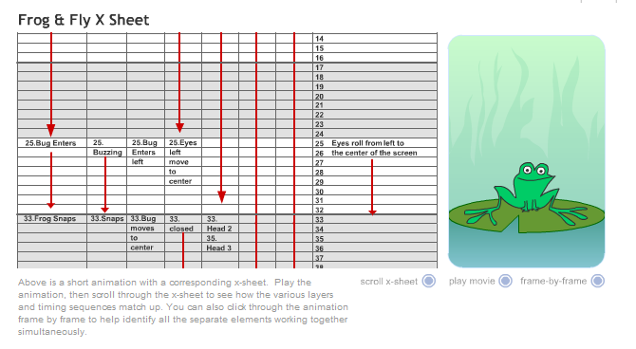
You can imagine, because of the highly structured nature of the animation process, it is important to plan the shots, audio, and sequences very carefully. The X-Sheet (sometimes also called a Dope Sheet) is a means to accomplish that. The X-Sheet is the graphical representation of each individual frame of a production, whether movie, ad film, or game. It is much like an Microsoft Excel sheet divided into rows and columns, and contains detailed description of the time for each action, the action's pace of movement, and the corresponding dialog. Each row constitutes a frame; and at the end of every sixteenth row on the sheet, a bold horizontal line marks one foot of the film. This is the traditional method of charting the time for an entire production, although some studios have customized the footage to 24 frames—denoting each second of animation—for convenience. The total number of frames on a page also varies from one studio to the other.

As for the presentation, frame numbers are charted on the left column of an X-Sheet and the other details on the right. Note that X-Sheets are read from the right to the left. Acronyms for the characters and objects are used as separate column heads, under which the details for the same appear.
In addition to time, the X-Sheet also contains detailed instructions for camera shots, dialog, sound track, music, and notes about the background for each scene. This is an important reference guide for the animator to use at the time of compositing because it shows the exact sequence of layering of backgrounds, number of frames for a dialog, sound, and music. Those of you who are familiar with the Flash interface will be aware of the concept of layering. The representation of layers in an X-Sheet is very similar.
The actions and dialogs are written in detail over the scenes. Each sentence of a dialog is measured and charted accordingly in the frames of an X-Sheet; this helps the animator synchronize the positions of the mouth with the words. The usual rate of animated speech is two-and-a-half words per second.
In some cases, when only a particular part of a character, such as the head, a hand, or a leg, needs to be shown in a scene, the animator notes this under a unique column head instead of under the same column for the character.
One of the primary uses of the X-Sheet is to determine the placement of keys and inbetween shots. When creating animations it's not enough to know how to move a character or an object. Certain other aspects also need to be considered, such as:
- Perfecting the key positions to create believable actions
- Selecting the best way to stage an action
- Deciding on a suitable soundtrack for a particular sequence

Placement of Keys
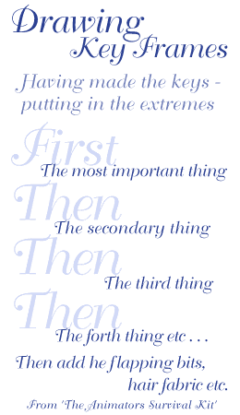
Over the next couple of weeks, we will talk about each of these three aspects, this week we will discuss the position of keys
In Week 1 you learned that the principles of animation, such as timing, ease-in, ease-out, and appeal, are used to create smooth and appealing movements. But what determines these principles in the sketches you create is the placement of each sketch. The placement of key poses and inbetweens with respect to the extremes, and the spacing between each of these, controlled the smoothness and clarity of an action. The first lecture of this week discusses how to space inbetweens to achieve the desired effects.
Start by recalling the stage at which inbetweens come in. When drawing an animated move, you first draw the "extremes" or the end poses, such as the two end positions of a pendulum, then the "key" poses (also called the storytelling poses) or the frames indicating the next pose, and finally the inbetweens to indicate the movement.
Let's look at an example to understand the placement of inbetweens.
In the animation of a character starting to run from one point, crossing a hurdle in the middle, and then continuing to run until the finishing line, the key poses will be:
- The starting position of the character—call it Key 1
- The position at which the character crosses the hurdle—call it Key 10
- The finish-line position—call it Key 20
Notice here that the first and third positions are the extremes. As every action starts and ends slowly, you need to add inbetweens near the extreme positions to indicate this. Add two inbetweens after Key 1, naming them Key 2 and Key 3 respectively, and two before Key 20, naming them Key 18 and Key 19 respectively. This will ensure ease-out and ease-in movements at these positions. If instead, the inbetweens Keys 2 and 3 were placed exactly in the center of Keys 1 and 10, the action would look boring.

The number and position of inbetweens control the fluidity of a movement: the more positions and closer the inbetweens, the more fluid the movement. But evenly spaced inbetweens through an entire action sequence may ruin the impact of the action. In the previous example, suppose the character is unaware of the hurdle in his way; then the number of inbetweens before Key 10 will increase and become more irregularly spaced to show sudden transitions. Therefore for most actions, inbetweens towards the middle of an action are regularly spaced, but those at the beginning and the end of the action are spaced according to the timing and style of the intended action.
When deciding on an action an animator creates a "ladder" or "breakdown" indicating the:
- Number of inbetweens
- Spacing between a key and an inbetween
- Spacing between two inbetweens
Note: Remember that the key positions should be the most expressive ones, and should appear on the screen for a longer time than the inbetweens.
While positioning keys for an action consider the following:
Object dimensions: The size and volume of an object should be uniform throughout an animated sequence. Details such as the height and edges of objects should be consciously maintained in all of the inbetweens to avoid a wobbly effect. But if the size or volume of an object needs to be exaggerated or stretched, the proportions of the object should show a uniform change.
Joints: While animating a human figure the parts of a body connected through joints need to be animated separately. If an arm is animated as a single entity, the effect will be rubbery and unrealistic, which is not desirable. To avoid this, bend the arm at the joints and animate each part separately. Similarly, to achieve smooth movement in a nonliving object, such as a cardboard box, substitute joints with the folds, sides, and edges of the object.

Lip Syncing
Another important use of the X-Sheet is to coordinate the audio (dialogue, sound effects, and music) to the proper frames of the animation sequence. Using the X-Sheet, musical scores can be choreographed to each musical notation, and the lips of a character can be made to move with the dialogue being spoken.
Lip syncing is the morphing of lips of a character from one shape to another so they match the shape of the mouth and head to the words being spoken, making the animated character appear to be talking or singing. An animated character is a synergistic combination of facial expressions, gestures, and dialogue. Therefore coordinating the proper lip sync for a character's gestures and expressions is important. Animators achieve this by drawing different mouth shapes for the character and moving them with respect to the audio, to create an illusion of speech.
You may have noted that you create a different effect when you say the same sentence at different speeds. This is why you need to listen to the track to synchronize the mouth positions with the track timing. While listening to the audio, measure the timing of each phoneme, enter the alphabets of each sentence over the required number of frames, and indicate holds—or empty frames, and drags—the extent of an alphabet over more than one frame. The same is true for songs. In the reverse case, if lip syncing is performed for each word of the sentence, the number of frames of the animation may increase, slowing down the pace of action.
Animators use standard model sheets containing mouth patterns corresponding to the important phonemes used in dialogues. Different lip shapes are used for different emotional states of a character. The animator who creates lip sync for characters refers to the column containing the dialogs in the X-Sheets, decides on a corresponding lip shape from his model sheets, and records the name of that lip shape in the column alongside the dialog. An interesting fact about lip syncing is that the mouth positions are not created exactly for the same frames as the alphabet of the dialog; they are usually placed a couple of frames later.
Corresponding facial expressions, such as eye, eyebrow, and cheek movements, also need to be incorporated to create realistic animation. Animators usually store a set of such movements in a library to save tedious redrawing. Software tools such as Magpie Pro allow you to tilt, reverse, invert, expand, and contract these movements to provide variety in the expressions of the character. Expressions also depend on the rise and fall of the voice in a dialog or song. A voice usually rises on important words and falls on the less important ones.
Note: Although lip syncing is not very important in animation for 2D games, it can however be used to convey the message of the main character. Synchronization of the head and the body is more important to hold the viewers' interest.

Lip Syncing
Another important use of the X-Sheet is to coordinate the audio (dialogue, sound effects, and music) to the proper frames of the animation sequence. Using the X-Sheet, musical scores can be choreographed to each musical notation, and the lips of a character can be made to move with the dialogue being spoken.
Lip syncing is the morphing of lips of a character from one shape to another so they match the shape of the mouth and head to the words being spoken, making the animated character appear to be talking or singing. An animated character is a synergistic combination of facial expressions, gestures, and dialogue. Therefore coordinating the proper lip sync for a character's gestures and expressions is important. Animators achieve this by drawing different mouth shapes for the character and moving them with respect to the audio, to create an illusion of speech.
You may have noted that you create a different effect when you say the same sentence at different speeds. This is why you need to listen to the track to synchronize the mouth positions with the track timing. While listening to the audio, measure the timing of each phoneme, enter the alphabets of each sentence over the required number of frames, and indicate holds—or empty frames, and drags—the extent of an alphabet over more than one frame. The same is true for songs. In the reverse case, if lip syncing is performed for each word of the sentence, the number of frames of the animation may increase, slowing down the pace of action.
Animators use standard model sheets containing mouth patterns corresponding to the important phonemes used in dialogues. Different lip shapes are used for different emotional states of a character. The animator who creates lip sync for characters refers to the column containing the dialogs in the X-Sheets, decides on a corresponding lip shape from his model sheets, and records the name of that lip shape in the column alongside the dialog. An interesting fact about lip syncing is that the mouth positions are not created exactly for the same frames as the alphabet of the dialog; they are usually placed a couple of frames later.
Corresponding facial expressions, such as eye, eyebrow, and cheek movements, also need to be incorporated to create realistic animation. Animators usually store a set of such movements in a library to save tedious redrawing. Software tools such as Magpie Pro allow you to tilt, reverse, invert, expand, and contract these movements to provide variety in the expressions of the character. Expressions also depend on the rise and fall of the voice in a dialog or song. A voice usually rises on important words and falls on the less important ones.
Note: Although lip syncing is not very important in animation for 2D games, it can however be used to convey the message of the main character. Synchronization of the head and the body is more important to hold the viewers' interest.
Explore:
Sounding out words: http://mag.awn.com/index.php3?ltype=cat&category1=Tutorials&article_no=1444
Annosoft Lip syncing software tool: http://www.annosoft.com/phoneset.htm
SeeStorm lip synchro: http://demo.seestorm.com/content/avatarvideo.wmv
LipSync for Director: http://www.mediamacros.com/item/item-951103756/
LipSync Software: http://www.3dlinks.com/links.cfm?categoryid=1&subcategoryid=71

Layout & Background
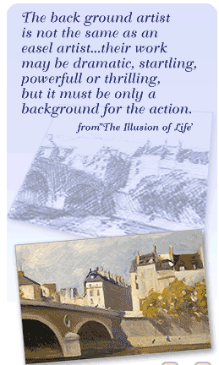
Backgrounds
We now come to creating the setup or location where the events take place. After a layout artist has provided directions for the background in each scene, a background artist completes it with detailing and coloring. Technically speaking, background is the colored version of the layout. Being the lowermost layer in an animation, background helps build the atmosphere and mood of the story. Making a background is one of the activities in the ink and paint phase of the cel animation process.
A background artist has to consider the:
- Factors that will build the mood of a scene
- Colors of the characters that will appear over the background
- Required details depending on the length of the animation
Mood
A background artist exercises a lot of control in enhancing the sequence of a scene. If a scriptwriter has missed any details, the background artist fills in the blanks. For example if a script contains information only about a season, say winter, the background artist has to visualize whether a night sky, heavy fog, and leafless trees can jell with the remaining scenes. Tempest scenes on a sea definitely look good against a night background turning gradually darker with a full moon peering through the clouds! Explicit details help you clearly build the mood of a scene.
Colors
A good sense of color (hues and saturation) is a requirement for any background artist. A background artist has to be cautious not to override a scene with bright background colors; this takes attention away from the actual action. At times alternate sets of colors for the characters and background are created to suit a particular time of the day. For example, morning grass is usually depicted in a yellow shade while evening grass has a distinct bluish tinge. The artist's concern should be to select background colors that are compatible with those of the characters. A judicious combination of loud and soft colors helps decrease the monotony of a background. Consider Night on Bald Mountain from Disney.
Explore:
Sketching on Location – Texture as planes in space: http://mag.awn.com/index.php?ltype=cat&category1=Tutorials&article_no=63
Let’s sketch on location: Organizing and creating space
http://mag.awn.com/index.php?ltype=cat&category1=Tutorials&article_no=81

Details
While creating details for background objects, you first consider the length of the animation. An "animation short" will not need as much detailing as a full-length animation because there is less time involved in registering. In addition the camera angles for each scene need to be considered. The background perspective should match with the character's perspective in the foreground. A long shot of a city with intricate detailing on the high-rise buildings may appear fine, but the same scene in a close-up shot with as much detailing may appear cluttered. A background artist has to customize the detailing accordingly.
Sometimes an animation sequence requires panning the background. You need to depict a character who's running through a jungle. The jungle scene in the background can be moved in a direction opposite to the character to show the distance being covered. To create the illusion of depth in such scenes, the background is composed of two or three layers as you learned in the layout section. While animating, the three layers should be moved at different speeds—the layer closest to the foreground will move the fastest, and the layer farthest away will move the slowest.
In addition to the above, a background artist needs to research the overall setup of the story considerably. Research areas include:
Period architecture - An artist needs to have a sound knowledge of the characteristic architecture of houses, buildings, and furniture of different eras. For example, showing the Statue of Liberty in the background of a game set in the eighteenth century is inappropriate. Conduct a research for more information on architecture.
Period technology - A sound knowledge of the technological limitations of an age is important. A light bulb in the background of a game set in the early nineteenth century will only reflect the lack of research by the development team.
In the past the medium used for coloring a background ranged from crayons to pastels and oil paints. Artists such as Art Heineman even used colored paper instead of paint in the film The Greatest Man in Siam. In those days backgrounds were mostly drawn on sheets of paper or cels.The coloring medium was selected by the quality of the characters and the mood of the story, whether fairy tale or action-oriented such as Superman! The same guidelines are applicable today also. Notice the cartoon hero Dexter: a geometric character with an edgy, pixilated background!
Today the arduous process of coloring the background on each cel has been replaced by specialized software such as Painter, Photoshop, Flash, and FlipBook. Painter has emerged as popular software because of many built-in tools that help simulate "natural media" such as watercolors, pastels, oils, and natural effects such as fire.

Layout of Background - I
Planning a layout for a scene means setting the position of a character against a specific background. It is similar to the stage of a theater, where the characters are set against different sceneries that make up the environment of the story. Clues for the background are located in the script and sometimes in the storyboard.
Backgrounds for animation are drawn on long sheets of paper, and a layout artist selects exact portions of the background for each scene. Consider the character Tim. Suppose the background sheet for Tim contains his house, a couple of neighboring houses, the nearby park, a shopping mall, and the road connecting these areas to each other. The layout artist plans exactly how much of each area should be present in the first, second, and the succeeding scenes. In addition, the artist plans the perspective of a character against the perspective of the background.
When planning layouts, artists work with rough sketches of backgrounds in which the locations for each event is clear. Most of the times the layout artist has to plan for multiple backgrounds or layers of background for a scene. Once approved by the team, the background artist (in some studios it is the same layout artist) can detail and color the background objects.
Layout of Background - II
Sometimes in animations more than one background is used. Here the backgrounds have to be set in layers, one above another. The background artist decides on the layout of the layers.

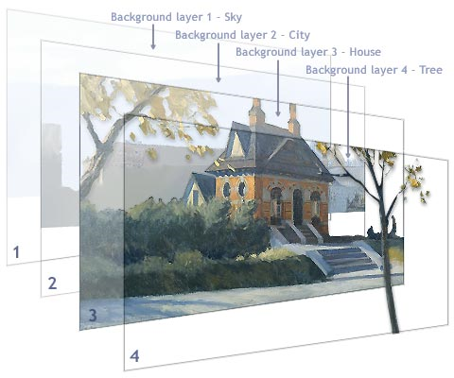

Layers in Layout - II
A good example of a multilayered background was observed as early as the 1980s when Disney published the arcade game Hercules. The significant feature of the game was that the player was allowed to move somewhat into the background, which consisted of a forest scene, and collect pickables such as "Health" coins. And contemporary racing games such as the Nascar Racing series have also employed the concept of multiple layers. While riding through a country track the players catch glimpses of the distant hills and industrial establishments, which are actually layers of background.
Role of Camera in Layout
The camera also plays a vital role in a layout. The camera point of view (POV) or focus is adjusted each time a new event takes place in the story. The layout artist selects certain parts of a background for each scene and also decides on various framing angles for the scenes. Where a storyboard artist gives a rough account of the camera shots and characters in a scene, the layout artist decides the exact position and perspective of each character in the scene. The layout artist sets each sequence of the storyboard in the best perspective to convey the right kind of emotion to the audience.
Let's take a look at a scenario that will help you understand the role of the camera. You have to animate a comic character swimming in the sea who suddenly mistakes a ship as a huge whale, and passes out. You design the layout of the initial swim course like this:
- The character appears at the left side of the scene.
- A broad background shows an expanse of sea, part of the beach, and the horizon line in the distance.
As the story progresses you keep moving the camera so that character moves to the right and the background keeps varying. In the climax, the character is set in the center of the scene, facing the corner of the ship. A background is not necessary in this scene, but one showing part of the sky can be used.
An artist considers altering the background angle instead of limiting it to one constant horizontal pattern. Sometimes better action can be established by tilting the background at a certain angle. Think of animations like boats sailing on a rough sea or a character walking uphill. It will be a difficult task to synchronize the boats with the waves or the character with the incline of the hill in each scene; the ultimate output may not be convincing. Instead, inclining the background scene and creating accurate expressions on the characters can help achieve a better effect.
Today specialized software has helped artists tremendously. The manual processes of designing layout, inking and painting, scanning, and creating backgrounds and animation, have all been replaced by computerized processes. Using programs such as Painter, Photoshop, and Premier, we can still work with layers in our background that can be easily changed and manipulated. Many programs also give us means of controlling the light source and depth of field to create more dramatic and natural scenes.
Assignment 1: Sketches and Discussion
As we've stressed since the beginning of this course, in order to be a good animator you need to observe the movements of real life. Begin the exercise right away, so that it gradually becomes a habit. Make the following observations and submit a series of sketches of your findings to the Discussion Area by Friday, September 5, 2008:
Stand in front of a mirror and observe the shape of your lips as you form words and vowels. Sketch your lips speaking the word “Hello,” and post your sketches to the discussion board. Again, store the sketches in your virtual handbook.
Critique and discuss at least two of your classmates' sketches by the end of the week.
By Friday, September 5, 2008, respond to the discussion questions assigned to you by the facilitator. Submit your responses to the appropriate topic in this Discussion Area. Start reviewing and responding to your classmates as early in the week as possible.
Assignment 1 Grading Criteria | Maximum Points
Sketching:
Submitted five scanned sketches representing a single movement. | 12
Sketches reflected the essence of the situation. | 8
Actively participated in the discussion. Reviewed and responded to questions and comments submitted by others. | 4
Discussion:
Demonstrated significant observations on character design. | 8
Justified statements and conclusions with appropriate references or examples. | 8
Demonstrated the ability to think innovatively. | 4
Actively participated in the discussion. Reviewed and responded to questions and comments submitted by others. | 8
Total: | 52
For assistance with any problems you may have when completing this assignment—OR—to offer your assistance to classmates, please use the Problems and Solutions Discussion area located through the left side navigation link.
This week I just want to talk about people's sketches. Please give one thing you like and one thing that can be improved on.
Assignment 2: Tripping Tim Final Project: Creating a Background
By Friday, September 5, 2008, sketch a detailed background for Tim, showing his house, the garden, the path leading to his gate, and the neighboring house where kids are playing. Exclude the chair, table, ball, and banana peel from the background; because Tim will interact with these objects, these need to be drawn as separate objects on different layers. Be careful about the dimensions of the background objects, as they will have a bearing on the animation.
Scan and color the background using any software of your choice. Save the file as .gif, and post to this Discussion Area. Review and critique the work of at least two other students by early in the week.
Assignment 2 Grading Criteria | Maximum Points
Created a background that is suitable for the story of Tim's tragedy. | 8
Included background details mentioned in the script. | 8
Used the correct perspective for the background. | 4
Identified areas of improvement in other's backgrounds and provided unique and constructive suggestions. | 8
Actively participated in the discussion. Reviewed and responded to questions and comments submitted by others. | 8
Actively participated in the Problems and Solutions discussion forum. | 4
Total: | 40
For assistance with any problems you may have when completing this assignment—OR—to offer your assistance to classmates, please use the Problems and Solutions Discussion area located through the left side navigation link.
I want you to take your background drawings from last week and improve on them. Consider not just what the script says but add style and personality to the design. What kind of place would Tim live in? Would his yard be clean or cluttered?
Assignment 3: Tripping Tim Final Project: Animating Tim
Draw the side-profile sequence of Tim as he gets up from his chair and walks towards the ball. Do a line test of the sequence using the animation software, and submit the .mov file to this Discussion Area by Sunday, September 7, 2008. As in Week 3 perform the line test by drawing each frame on a separate sheet and shooting the frames using a digital camera attached to the computer.
Try to incorporate the principles of animation and the suggestions of your peers in your animation. Review and critique the work of at least two other students early in the week.
Assignment 3 Grading Criteria | Maximum Points
Created smooth transition between poses. | 12
Showed clear body language and Tim's eagerness to reach for the goal. | 4
Timed the walk correctly. | 8
Actively participated in class discussions. | 4
Actively participated in the Problems and Solutions discussion forum. | 4
Total: | 32
For assistance with any problems you may have when completing this assignment—OR—to offer your assistance to classmates, please use the Problems and Solutions Discussion area located through the left side navigation link.
This week i really want you to focus on timing. Try to build on the walk and what you learned from last week and really make sure the timing of your animation is nice. Think about ease ins and outs. Also make sure your animations are long enough to get a sense of the movement.
Assignment 4: Sketching
By Tuesday, September 9, 2008, modify your sketches and the corresponding animation, based on the feedback given by your peers. Scan five of your modified sketches and submit them to this Discussion Area. Select the best sketches and add them to your Virtual Handbook that you'll submit in Week 6.
Assignment 4 Grading Criteria | Maximum Points
Modified the animated sequence. | 8
Incorporated suggestions. | 4
Actively participated in the Problems and Solutions discussion forum. | 4
Total: | 16
For assistance with any problems you may have when completing this assignment—OR—to offer your assistance to classmates, please use the Problems and Solutions Discussion area located through the left side navigation link.
making corrections is a big part of working in the industry. Most of the time you will have things to improve on. So we are going to go back and do the same thing!

